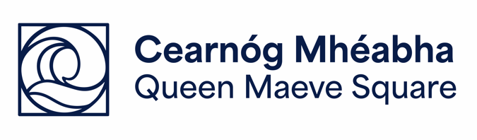
TERMS OF AGREEMENT FOR HIRING QUEEN MAEVE SQUARE FOR SMALL SIZE EVENT

BACKGROUND
In November 2024, Sligo BID entered a Service Level Agreement with Sligo County Council for the management of Queen Maeve Square.
The rules and regulations and associated fees are set by Sligo County Council.
This agreement is between Sligo BID and the Event Organiser.

BOOKING POLICY
- A Event Application Form must be completed in full in relation to the proposed dates of the event. Dates will not be confirmed until application has been approved.
- An administration fee of €75 (Ex VAT) will apply to all applications.
- Where events are deemed to be commercial, an additional rental fee will apply.
- On completion of submission of your documentation, an invoice is issued to the Event Organiser.

PAYMENT
- Queen Maeve Square administration fee is payable to the dedicated Queen Maeve Square bank account, and rental fee where applicable.
- All other event costs are the event organisers’ responsibilities, and where applicable this may include utility costs.
- Payment must be received prior to the event commencement date, or Event Agreement will be revoked.

PHOTOGRAPHY
- Please note if photography is taking place, the attendees of events should be alerted to this. It will be a matter for the Event Organiser to provide appropriate signage for the duration of their event. See below for sample wording.
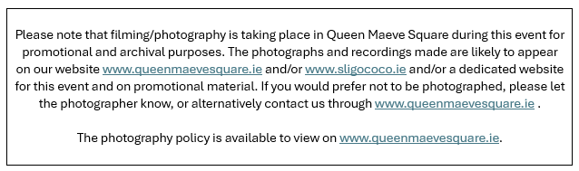
- Post event, a selection of event photos and videos should be shared with the Sligo BID team for promotional and archival purposes. Please note this footage will be shared with Queen Maeve Square partners including Sligo County Council and Fáilte Ireland.

OTHER
- Accessibility should be considered for all events in Queen Maeve Square. Please refer to the Sligo DPO Event Document for additional information.
- All rubbish must be removed post event by the Event Organiser and/or vendor. A Leave no Trace approach will be adopted for all events in Queen Maeve Square.
- The Council and Sligo BID expect Event Organisers to hand back the Square in the same manner that it was received – litter free, clean and tidy, all event props / infrastructure removed in a timely manner. Failure to adhere to same could result in the application of additional charges.
- Promotional materials for events must feature the logos of Queen Maeve Square, along with any other event funders or sponsors. The Purple Flag logo is recommended to be used for events held after 6pm.
These logos can be downloaded from our website www.queenmaevesquare.ie

HEALTH AND SAFETY
- Any event with children in attendance must have a child safeguarding statement and procedures in place.
- Sligo BID and Sligo County Council bear no responsibility for the management of safety for the duration of the event.
- The event organiser must comply with all relevant Health and Safety Legislation.
- Emergency access must be maintained at all times.

POST EVENT
- A short summary report including social media analytics and PR profile of the even must be submitted by the event organiser.
- A short digital survey for the event will be provided by the Sligo BID team and Event Organisers are asked to disseminate this event survey to their attendees, where appropriate.

COMMERCIAL HIRE RATES
Description / Duration | Rate (Ex Vat)
Hourly rate | €60
Half day (5hrs or less) | €250
Daily rate (8am to 11pm) and from 1 to 3 days | €500
Discounted daily rate (from day 4 to day 7) | €375
Weekly hire rate | €3,000

For commercial hire periods in excess of 7 days, applicants are advised to liaise directly with Sligo County Council.
I agree to the above Terms, Conditions and Prices;

Event Organiser Signature:
______________________________
Date:



